Labaratoriya-8

Mavzu:PHP orqali fayl yuklash va saqlash moduli

Ishning maqsadi
PHP dasturlash tilida foydalanuvchidan fayl qabul qilish, uni serverga xavfsiz yuklash va saqlash mexanizmini o‘rganish.

Nazariy qism
Fayl yuklash jarayoni qanday kechadi?
- Foydalanuvchi brauzer orqali faylni tanlaydi.
- Forma enctype="multipart/form-data" atributi bilan yuboriladi.
- Server (PHP) faylni vaqtinchalik papkaga (tmp papkasi) joylashtiradi.
- PHP $_FILES superglobal massivini yaratadi.
- Dasturchi move_uploaded_file() funksiyasi yordamida faylni kerakli joyga ko‘chiradi.
$_FILES massivi tarkibi:
- name — foydalanuvchi yuklagan asl fayl nomi
- type — brauzer yuborgan MIME turi
- tmp_name — vaqtinchalik faylning serverdagi yo‘li
- error — xato kodi (0 — muvaffaqiyatli)
- size — fayl hajmi (baytlarda)
Xavfsizlik muammolari (Majburiy yozing!):
- Noto‘g‘ri fayl turlarini yuklash (masalan .php, .phtml)
- Fayl nomida yo‘l traversal hujumi (../../)
- Double extension hujumi (photo.jpg.php)
- Fayl hajmini cheklamaslik (DoS hujumi)
- MIME type spoofing (fayl turini soxtalashtirish)
Xavfsiz fayl yuklashning asosiy qoidalari:
- Faqat ruxsat etilgan fayl kengaytmalarini qabul qilish (whitelist)
- Fayl hajmini cheklash (ikkala tomondan: php.ini va kodda)
- Fayl nomini o‘zgartirish (vaqt + tasodifiy son)
- move_uploaded_file() funksiyasidan foydalanish
- Yuklangan fayllarni alohida papkada saqlash
- uploads papkasida script bajarilishini taqiqlash

Misol:Men bunda Urganch davlat universiteti sayti yarattim va undagi ariza bo’limiga fayl yuklashni qo’shdim.

elseif($page == 'ariza') {

if (isset($_POST['ariza_submit'])) {

$ism = trim($_POST['ism'] ?? '');
$fakultet = trim($_POST['fakultet'] ?? '');
$kurs = trim($_POST['kurs'] ?? '');
$jins = trim($_POST['jins'] ?? '');
$sana = trim($_POST['sana'] ?? '');
$ariza = trim($_POST['ariza'] ?? '');

$pasport = $_FILES['pasport'] ?? null;
$diplom = $_FILES['diplom'] ?? null;
$boshqa = $_FILES['boshqa'] ?? null;

if (empty($ism) || empty($fakultet) || empty($kurs) || empty($jins) || empty($sana) || empty($ariza)) {
echo "<div style='background:#f8d7da; padding:15px; color:#721c24; border-radius:6px; margin-bottom:20px;'>
Barcha maydonlarni to'ldiring!
</div>";
}
elseif (!$pasport || $pasport['error'] !== 0) {
echo "<div style='background:#f8d7da; padding:15px; color:#721c24; border-radius:6px; margin-bottom:20px;'>
Pasport yoki ID-karta yuklash majburiy!
</div>";
}
else {

$upload_dir = "uploads/";

if (!is_dir($upload_dir)) {
mkdir($upload_dir, 0777, true);
}

// Fayl yuklash funksiyasi
function uploadFile($file, $prefix, $upload_dir) {
if ($file && $file['error'] === 0) {
$ext = strtolower(pathinfo($file['name'], PATHINFO_EXTENSION));
$new_name = $prefix . "_" . time() . "_" . rand(1000, 9999) . "." . $ext;
$target = $upload_dir . $new_name;

if (move_uploaded_file($file['tmp_name'], $target)) {
return $new_name;
}
}
return null;
}

$pasport_name = uploadFile($pasport, "pasport", $upload_dir);
$diplom_name = uploadFile($diplom, "diplom", $upload_dir);
$boshqa_name = uploadFile($boshqa, "boshqa", $upload_dir);

if ($pasport_name) {

$stmt = $conn->prepare("INSERT INTO arizalar
(ism, fakultet, kurs, jins, sana, ariza, pasport, diplom, boshqa)
VALUES (?, ?, ?, ?, ?, ?, ?, ?, ?)");

$stmt->bind_param("sssssssss",
$ism, $fakultet, $kurs, $jins, $sana, $ariza,
$pasport_name, $diplom_name, $boshqa_name);

if ($stmt->execute()) {
echo "<div style='background:#d4edda; padding:15px; text-align:center; border-radius:6px; margin-bottom:20px;'>
✅ Ariza va hujjatlar muvaffaqiyatli yuborildi!
</div>";
} else {
echo "<div style='background:#f8d7da; padding:15px; color:#721c24;'>Bazaga yozishda xatolik!</div>";
}
$stmt->close();
} else {
echo "<div style='background:#f8d7da; padding:15px; color:#721c24;'>Pasport faylini yuklashda xatolik!</div>";
}
}
}

?>
<section style="padding:60px 0;">
<div class="container">
<form method="POST" enctype="multipart/form-data" style="max-width:700px; margin:0 auto; background:#fff; padding:30px; border-radius:12px; box-shadow:0 8px 20px rgba(0,0,0,0.1);">

<h2 style="text-align:center; margin-bottom:30px;">Talaba Ariza Yuborish</h2>

<input type="text" name="ism" placeholder="Ismingiz" required style="width:100%; padding:12px; margin-bottom:15px; border:1px solid #ddd; border-radius:6px;">

<input type="text" name="fakultet" placeholder="Fakultet" required style="width:100%; padding:12px; margin-bottom:15px; border:1px solid #ddd; border-radius:6px;">

<input type="text" name="kurs" placeholder="Kurs" required style="width:100%; padding:12px; margin-bottom:15px; border:1px solid #ddd; border-radius:6px;">

<label style="font-weight:bold;">Jinsi:</label>
<div style="display:flex; gap:25px; margin:10px 0 15px;">
<label><input type="radio" name="jins" value="Erkak" required> 👨 Erkak</label>
<label><input type="radio" name="jins" value="Ayol" required> 👩 Ayol</label>
</div>

<label style="font-weight:bold;">Tug‘ilgan sana:</label>
<input type="date" name="sana" required style="width:100%; padding:12px; margin-bottom:15px; border:1px solid #ddd; border-radius:6px;">

<textarea name="ariza" placeholder="Ariza matni" required style="width:100%; padding:12px; margin-bottom:15px; border:1px solid #ddd; border-radius:6px; height:120px;"></textarea>

<div style="background:#f8f9ff; padding:25px; border-radius:12px; border:2px solid #007bff; margin-top:25px;">
<h3 style="color:#007bff; margin-bottom:20px;">📎 Hujjatlar yuklash</h3>

<div style="margin-bottom:20px;">
<label style="display:block; font-weight:bold; margin-bottom:8px;">Pasport yoki ID-karta (majburiy)</label>
<div style="border:2px dashed #007bff; border-radius:8px; padding:20px; text-align:center; background:#fff;">
<input type="file" name="pasport" id="pasport" accept=".jpg,.jpeg,.png,.pdf" required style="display:none;" onchange="showFileName(this, 'pasport-name')">
<label for="pasport" style="cursor:pointer; color:#007bff;">📄 Faylni tanlang yoki shu yerga torting</label>
<p id="pasport-name" style="margin-top:10px; color:#555;"></p>
</div>
</div>

<div style="margin-bottom:20px;">
<label style="display:block; font-weight:bold; margin-bottom:8px;">Diplom yoki Attestat</label>
<div style="border:2px dashed #28a745; border-radius:8px; padding:20px; text-align:center; background:#fff;">
<input type="file" name="diplom" id="diplom" accept=".jpg,.jpeg,.png,.pdf" style="display:none;" onchange="showFileName(this, 'diplom-name')">
<label for="diplom" style="cursor:pointer; color:#28a745;">📄 Faylni tanlang yoki shu yerga torting</label>
<p id="diplom-name" style="margin-top:10px; color:#555;"></p>
</div>
</div>

<div style="margin-bottom:25px;">
<label style="display:block; font-weight:bold; margin-bottom:8px;">Boshqa hujjat (CV, sertifikat va h.k.)</label>
<div style="border:2px dashed #6c757d; border-radius:8px; padding:20px; text-align:center; background:#fff;">
<input type="file" name="boshqa" id="boshqa" accept=".jpg,.jpeg,.png,.pdf,.doc,.docx" style="display:none;" onchange="showFileName(this, 'boshqa-name')">
<label for="boshqa" style="cursor:pointer; color:#6c757d;">📄 Faylni tanlang yoki shu yerga torting</label>
<p id="boshqa-name" style="margin-top:10px; color:#555;"></p>
</div>
</div>
</div>

<button type="submit" name="ariza_submit" style="width:100%; padding:14px; background:#003366; color:white; border:none; border-radius:6px; font-size:16px; margin-top:20px; cursor:pointer;">
Yuborish
</button>
</form>
</div>
</section>

<script>
function showFileName(input, displayId) {
const fileName = input.files[0] ? input.files[0].name : "";
document.getElementById(displayId).textContent = fileName ? "📁 " + fileName : "";
}
</script>

<hr style="margin:50px 0;">

<h3>Yuborilgan Arizalar</h3>
<?php
$result = $conn->query("SELECT * FROM arizalar ORDER BY created_at DESC");

if ($result->num_rows > 0) {
while ($row = $result->fetch_assoc()) {
echo "
<div style='background:#f8f9fa; padding:18px; margin-bottom:15px; border-radius:8px; border-left:5px solid #003366;'>
<strong>" . htmlspecialchars($row['ism']) . "</strong> | " . htmlspecialchars($row['fakultet']) . " | " . htmlspecialchars($row['kurs']) . " | " . htmlspecialchars($row['jins']) . "<br>
Tug‘ilgan sana: " . htmlspecialchars($row['sana']) . "<br><br>
" . nl2br(htmlspecialchars($row['ariza'])) . "<br>
<small style='color:gray;'>Yuborilgan vaqt: " . $row['created_at'] . "</small>
</div>";
}
} else {
echo "<p>Hozircha arizalar yo‘q</p>";
}
?>
<?php
Natija:
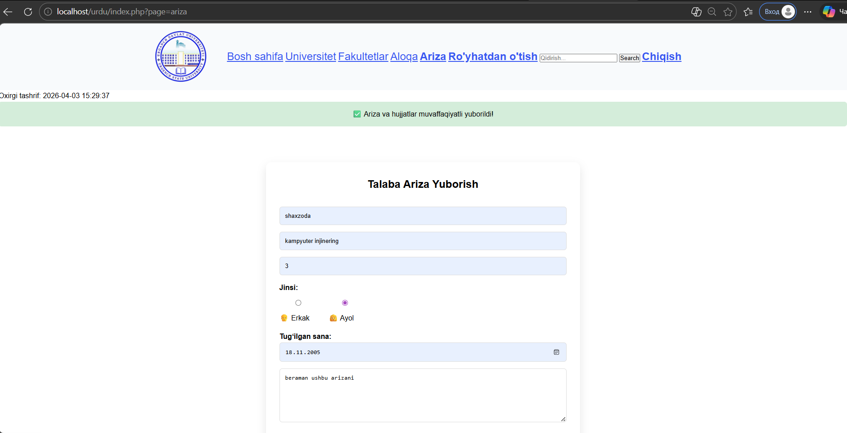
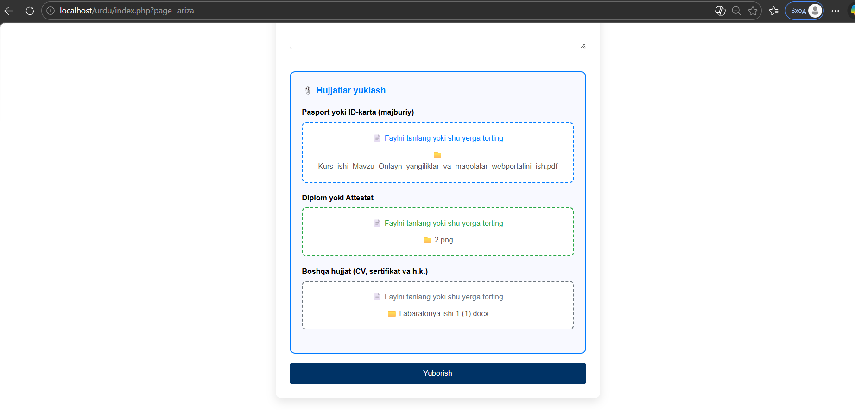
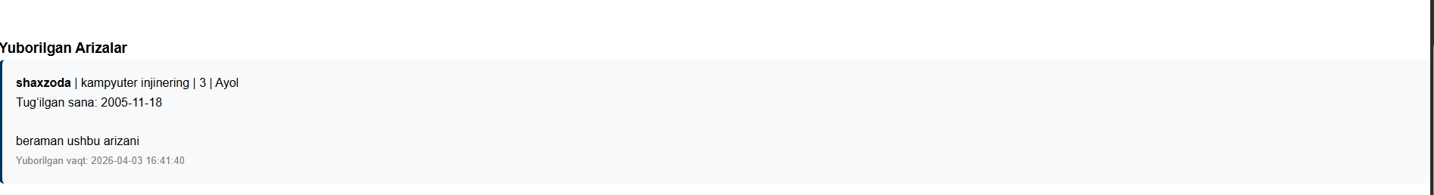

Uploads papkasiga tushadi yuklagan fayl va ma’lumotlarimiz.
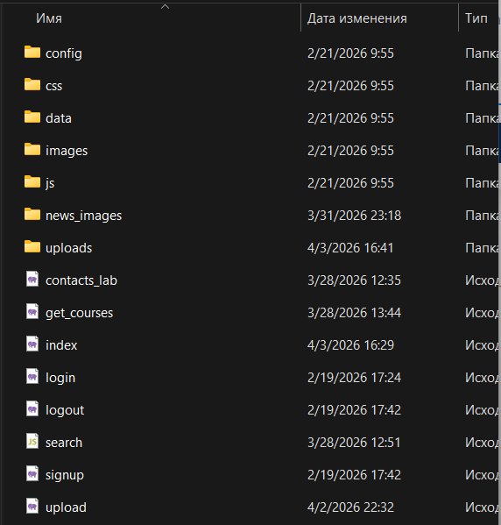
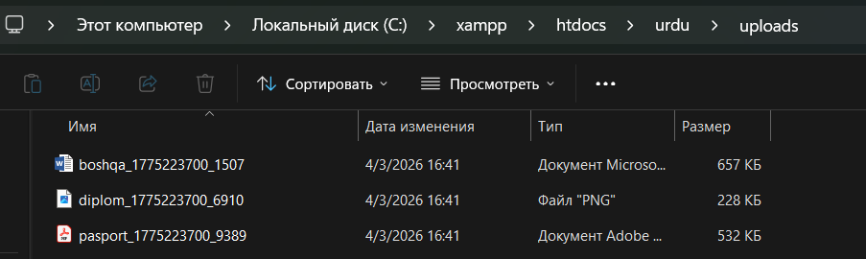

Xulosa
Ushbu laboratoriya ishida PHP tilida fayl yuklash va serverga saqlash mavzusini o‘rgandim. Formada enctype="multipart/form-data" ishlatish, $_FILES massividan foydalanish va move_uploaded_file() funksiyasi orqali faylni yuklashni amalda sinab ko‘rdim. Ish davomida fayl yuklash jarayonida yuzaga keladigan xavfsizlik muammolarini (masalan, noto‘g‘ri fayl turlarini yuklash, fayl nomini buzib yuborish) ko‘rib chiqdim va ularning oldini olish yo‘llarini o‘zlashtirdim. Fayl hajmini cheklash, ruxsat etilgan kengaytmalarni tekshirish va fayl nomini xavfsiz tarzda o‘zgartirishni amalda qo‘lladim. Natijada, PHP orqali fayllarni xavfsiz yuklash va saqlashni tushundim. Bu bilim kelajakda veb-saytlar va loyihalarda foydalanuvchidan fayl qabul qilishda juda foydali bo‘ladi.

